Supplementary information, Gawel et al. RSOS 17051

Supplementary Section 1: Sites

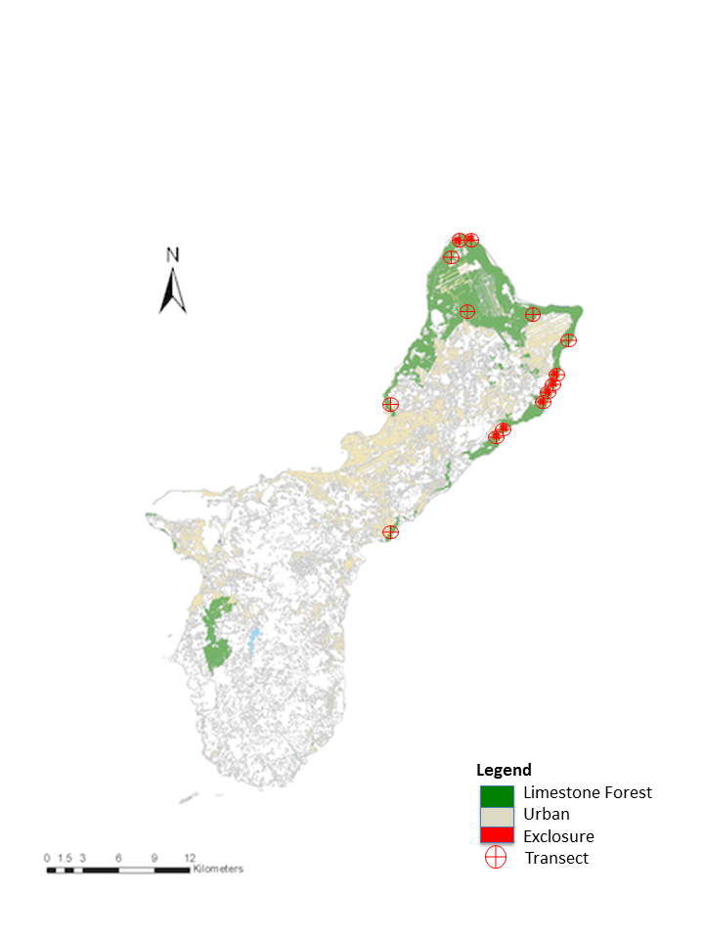

Supplementary Figure 1. Location of eight exclosures and 14 transects in Guam’s limestone karst forests.

Supplementary Section 2: Plots after removing highest deer and pig density sites.



Supplementary Figure 2. Results from vegetation and scat surveys dropping site that had highest scats per 100m2 ("Race" for pig, and "Tartop" for deer) to determine whether the extreme value was influencing the relationship between scat count and seedling abundance. Best fit lines are only included when the fit was significant at p=0.05. A loglinear relationship was a better fit for all of the deer-seedling relationships than a linear fit. Although the scale of the x-axis is smaller, trends are qualitatively the same as those in Figure 4.

Supplementary Section 3: Comparisons of baseline characteristics of seedling plots chosen for fenced and ungulate treatments.

Supplementary Table 1: Comparison of paired plots at each site, using number of adult trees, average diameter at breast height (dbh), canopy cover, and average adult tree height.

|  |  |  |  |  |  |  |  |  |
| --- | --- | --- | --- | --- | --- | --- | --- | --- |
|  | Fenced | | | | Unfenced | | | |
| Site | # Adult trees | Avg dbh (cm) | Canopy cover | Avg height (m) | # Adult trees | Avg dbh (cm) | Canopy cover | Avg height (m) |
| Ritidian Grid | 6 | 14.67 | 0.82 | 9.17 | 5 | 16.2 | 0.84 | 8.3 |
| Ritidian Gate | 7 | 14.57 | 0.9 | 8.71 | 5 | 11.2 | 0.85 | 7.6 |
| Anao North | 6 | 10 | 0.84 | 10.6 | 8 | 19 | 0.84 | 11.06 |
| Anao South | 7 | 12 | 0.73 | 9.43 | 11 | 6.45 | 0.79 | 9.43 |
| North Blas | 13 | 8.23 | 0.85 | 7.62 | 6 | 4.75 | 0.82 | 7.75 |
| South Blas | 8 | 6.13 | 0.76 | 6.88 | 6 | 6.67 | 0.74 | 7.67 |
| Racetrack | 14 | 4.93 | 0.9 | 6.21 | 10 | 4.93 | 0.9 | 6.65 |
| Racetrack Fragment | 12 | 4 | 0.88 | 7.46 | 9 | 4 | 0.89 | 6.67 |

Supplementary Table 2: We used linear mixed effects models with least square means posthoc tests to assess if the number of adult trees, proportion canopy cover, diameter at breast height of adult trees, and adult tree height differed significantly between treatments. We report output from the lsmeans tests below. We determined that these parameters do not differ significantly between seedling plots at each site, indicating plots were similar prior to the experiment.

|  |  |  |  |  |  |
| --- | --- | --- | --- | --- | --- |
| Parameter | Contrast values (Fenced – Unfenced) | | | | |
| Lsmean | Df | SE | t-ratio | p-value |
| # adult trees | 1.63 | 7 | 1.21 | 1.34 | 0.22 |
| Canopy cover | 0.00 | 7 | 0.01 | 0.11 | 0.92 |
| Height | -0.01 | 127.77 | 0.50 | -0.02 | 0.98 |
| DBH | 0.48 | 126.41 | 0.86 | 0.56 | 0.57 |

A.

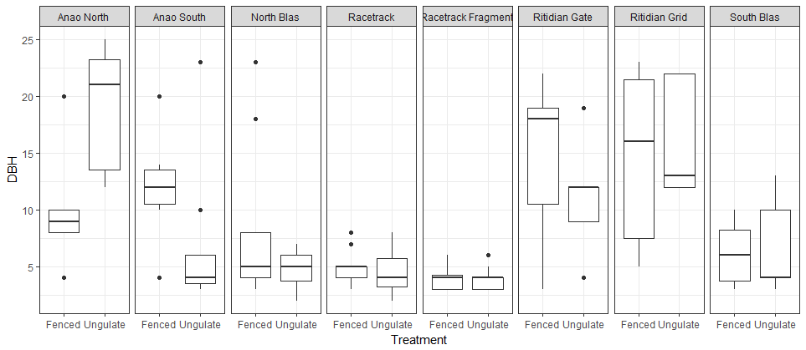

B.

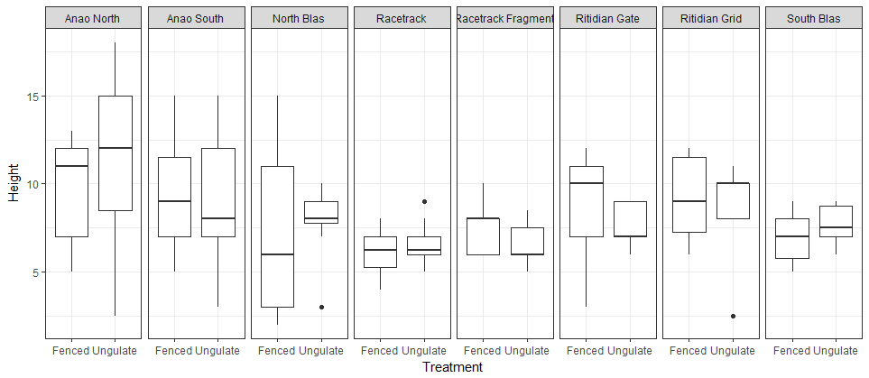

Supplementary Figure 3. Comparisons of DBH (a) and height (b) in adult trees in paired plots. While some differences are apparent, no consistent or unidirectional trends exist for either parameter across sites.

Supplementary Table 3. We included qualitative descriptions of the sites in the table below.

|  |  |  |  |
| --- | --- | --- | --- |
| Site |  | Fenced | Unfenced/Ungulate |
| Ritidian Grid | Substrate | Solid karst formations in southeast corner of plot, large amounts of *Ochrosia oppositifolia* leaf litter | Mostly flat with scattered limestone rocks 10-20 cm in diameter, mixed leaf litter |
|  | Slope | 0 | 0 |
|  | Species of adult trees | *Ochrosia oppositifolia, Aglaia mariannensis, Meiogyne cylindrocarpa* | *Ochrosia oppositifolia, Psychotria mariana, Cycas micronesica* |
| Ritidian Gate | Substrate | Mostly 5-10cm-diameter rocks with few large, 50-cm-high boulders, <20% exposed red soil | Few large, 50-cm-high boulders, <20% exposed red soil, mostly 5-10cm-diameter rocks |
|  | Slope | 0 | slight downward slope (<5 degrees) towards NW |
|  | Species of adult trees | *Ochrosia oppositifolia, Algaia mariannensis, Triphasia trifolia* | *Aglaia mariannensis, Mammea odorata, Ochrosia oppositifolia* |
| Anao North | Substrate | very rocky, no soil visible, rocks from 5 - 50-cm in diameter | very rocky, no soil visible, rocks from 5 - 50-cm in diameter |
|  | Slope | 0 | 0 |
|  | Species of adult trees | *Ochrosia oppositifolia, Meiogyne cylindrocarpa* (*Macaranga thompsonii,* out of plot, but canopy overhanging plot) | *Ochrosia oppositifolia, Cycas micronesica, Macaranga thompsonii* |
| Anao South | Substrate | 60% of ground cover is large rocks >20cm in diameter, some (~20% substrate) exposed red dirt | very rocky, loose rocks 10-50cm in diameter, small amounts (~10-15%) of exposed red dirt |
|  | Slope | flat | slight downward slope (<5 degrees) towards east |
|  | # adult trees | 7 | 11 |
|  | Species of adult trees | *Mammea odorata, Aglaia mariannensis, Meiogyne cylindrocarpa, Ochrosia oppositifolia* | *Mammea odorata, Ochrosia oppositifolia, Cynometra ramiflora, Meiogyne cylindrocarpa* |

|  |  |  |  |
| --- | --- | --- | --- |
| Site |  | Fenced | Unfenced/Ungulate |
| North Blas | Substrate | very rocky, no soil visible, rocks approx. 50cm in diameter | very rocky, no soil visible, rocks approx. 50cm in diameter |
|  | Slope | slight slope (<5 degs) downward towards NE, tower karst intermittent on all sides | in slight depression between towers of karst on north and south sides |
|  | Species of adult trees | *Aglaia mariannensis, Cynometra ramiflora, Morinda citrifolia, Macaranga thompsonii, Syzigium thompsonii* | *Aglaia mariannensis, Meiogyne cylindrocarpa, Mammea odorata* |
| South Blas | Substrate | very rugged, large, solid rocks on south side of plot, no soil showing | rugged, no soil showing |
|  | Slope | 0 | 0 |
|  | Species of adult trees | *Meiogyne cylindrocarpa, Ochrosia mariannensis* | *Meiogyne cylindrocarpa, Ochrosia mariannensis, Macaranga thompsonii* |
| Racetrack | Substrate | moderate karst, scattered boulders 0.5-m in diameter | moderate karst, scattered boulders and rocks 0.2 to 0.5-m in diameter |
|  | Slope | 0 | 0 |
|  | Species of adult trees | *Eugenia reinwardtiana* | *Eugenia reinwardtiana, Meiogyne cylindrocarpa* |
| Racetrack Fragment | Substrate | very rocky, high amount of *Eugenia* leaf litter | very rocky, high amount of *Eugenia* leaf litter |
|  | Slope | 0 | 0 |
|  | Species of adult trees | *Eugenia reinwardtiana, Aglaia mariannensis* | *Eugenia reinwardtiana* |

Supplementary Section 4: Model selection for linear models of vegetation characteristics explained by pig and deer scat abundance.

Supplementary Table 4. Total seedlings

K AICc ΔAICc

**Deer 3 206.06 0.00**

Deer + Pigs 4 209.55 3.49

Pigs 3 211.90 5.84

Supplementary Table 5. Native seedlings

K AICc ΔAICc

**Deer 3 202.53 0.00**

Deer + Pigs 4 205.93 3.40

Pigs 3 208.26 5.73

Supplementary Table 6. Exotic seedlings

K AICc ΔAICc

**Deer 3 156.83 0.00**

Pigs 3 159.64 2.81

Deer + Pigs 4 160.80 3.97

Supplementary Table 7. Vines

K AICc ΔAICc

**Deer 3 167.50 0.00**

Deer + Pigs 4 171.35 3.85

Pigs 3 174.59 7.09

Supplementary Section 5: Clarification on role of time in ground for planted seedlings.

Planting dates were staggered based on species. Because outplanting dates corresponded to species ready for outplanting, and since there are six species, we see that the time a seedling was in the ground fell tightly into six discrete groups, see boxplot below:

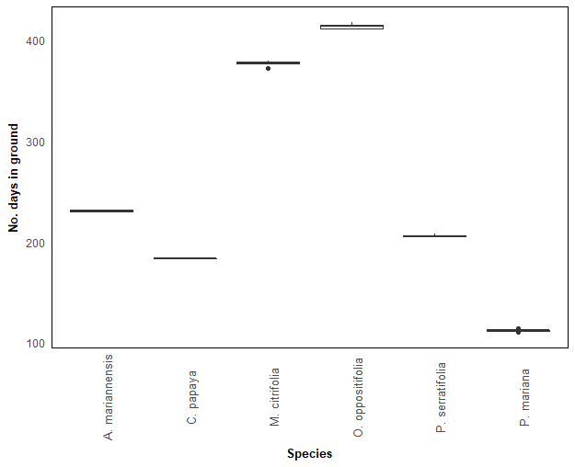

Supplementary Figure 4. Boxplot showing number of days seedlings of a certain species were in the ground (date recorded – date planted).

Therefore, to show that the number of days a seedling was in the ground did not affect differences in survival between treatments in a significant way, we created the following plot. It is similar to figure 1 of the manuscript, except species are ordered based on time they were in the ground (least number of days on the left, most on the right).

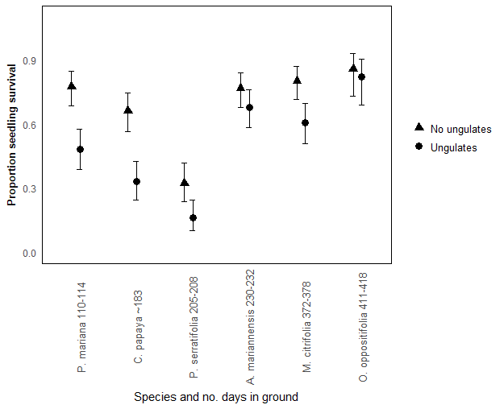

Supplementary Figure 5. Proportion of seedlings that survived in fenced versus unfenced plots for six tree species, showing that time in ground did not decrease survival or increase treatment effect.